Shopping Basket

User Manual

1. Reading the Shopping Basket

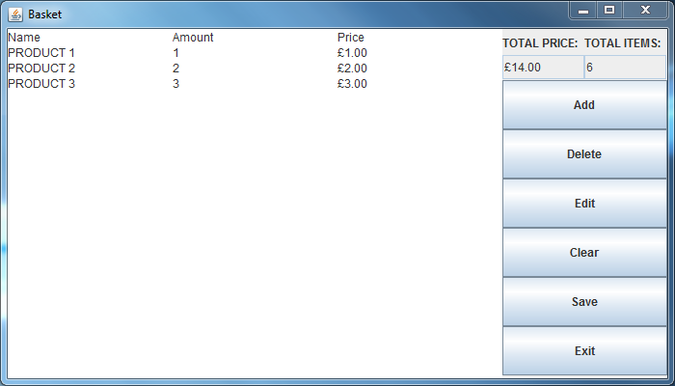Products are laid out in rows, as shown above with the three different product examples. The names of the products are shown below the ‘Name’ header, with the ‘Amount’ header preceding the quantity of each respective product in the basket one is purchasing, and the ‘Price’ header labelling the cost of each single product.

The cumulative price of the products is shown in the top right corner of the application, annotated with the header ‘TOTAL PRICE’. Beside this is the total number of items being purchased, ‘TOTAL ITEMS’.

1. Interacting with the Shopping Basket
   1. Adding to the basket

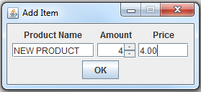

Clicking the Add button will result in this window being shown. Enter the name of the desired product to be added, the amount of the product to be purchased and the price of the product in order before clicking the ‘OK’ button in order to add the product to the list in the main application. Press the ‘X’ button in order to cancel.

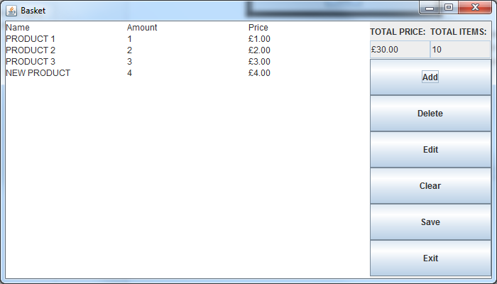

* 1. Deleting from the basket

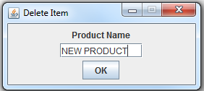

Click the ‘Delete’ button and you will be prompted to enter a product name. Enter the name of the product you wish to delete and click the ‘OK’ button. If the product exists, it will be removed from the shopping basket. Press the ‘X’ button in order to cancel.

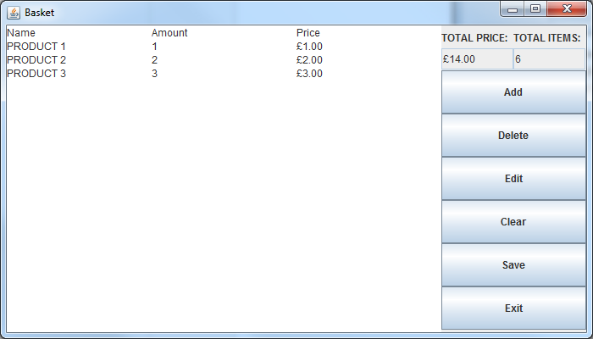

* 1. Editing the basket’s contents

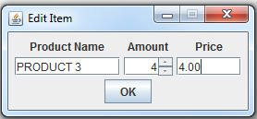

To edit an existing item in the basket, begin by clicking the ‘Edit’ button. Enter the name of the product you wish to modify in the ‘Product Name’ field, and the new amount and price figures in the next two fields. Click the ‘OK’ button. If the specified product exists, it will now possess the new values.

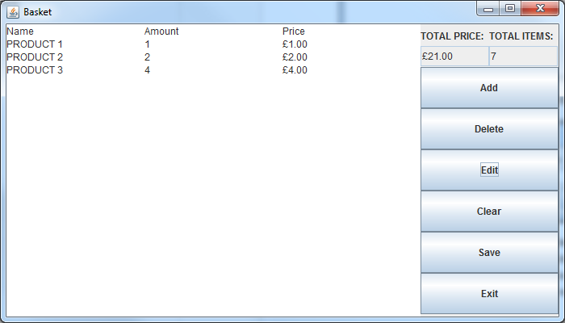

* 1. Clearing the basket

In order to clear the basket, simply click the ‘Clear’ button and all of the items currently in the basket will be removed.

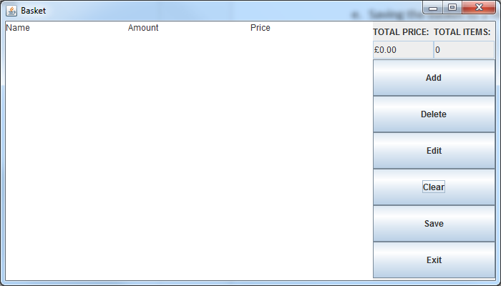

* 1. Saving the basket to a file

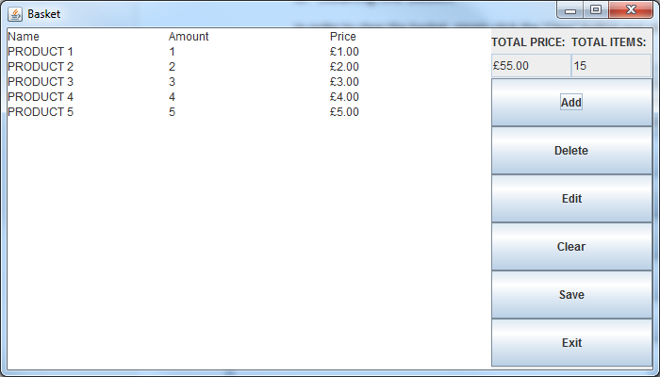

Once one has sufficiently filled the basket, one may save the contents by clicking the ‘Save’ button. This will record the contents in a file named ‘basket.txt’, which is saved in the same location as the application itself. The file will be opened in the default text editor if one is available.

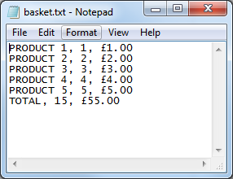

As shown above, the layout of the file is as follows:

NAME, AMOUNT, PRICE

The total quantity and price is also shown at the very bottom, in the order of total items preceding the total price.

* 1. Exiting the application

When you wish to exit the application, simply click the ‘Exit’ button or the ‘X’ button located in the bottom right and top right of the application, respectively. The program will closed.